SPATIAL EMANATOR PROJECT
Project details
Overview
The Spatial Emanator project is an innovative research initiative designed to generate robust entomological evidence on the effectiveness of spatial repellents, with the aim of informing decision-making by the World Health Organization (WHO) regarding their potential use as a malaria vector control tool.
In Benin, the project is led by the Centre de Recherche Entomologique de Cotonou (CREC), in collaboration with the African Institute for Research in Infectious Diseases (AIRID), and is supported by SC Johnson & Son Inc.

Project Description
Effectiveness of spatial emanators in the fight against malaria in Benin
Principal Investigator
Dr. Corine Ngufor
Background
The Spatial Emanator project is an advanced research initiative aimed at generating high-quality entomological evidence on the efficacy of spatial repellents as a complementary malaria vector control tool. Despite the widespread deployment of insecticide-treated nets (ITNs), residual malaria transmission persists, particularly in areas with high levels of insecticide resistance and outdoor or early evening mosquito biting. Innovative approaches are therefore urgently needed to strengthen existing control strategies and sustain malaria prevention gains.
This project seeks to evaluate the performance of spatial emanators under field and semi-field conditions, with the objective of informing policy recommendations by the World Health Organization (WHO). In Benin, the study is led by the Centre de Recherche Entomologique de Cotonou (CREC), in collaboration with the African Institute for Research in Infectious Diseases (AIRID), with support from SC Johnson & Son, Inc.
Project Objectives
- To evaluate the efficacy of SE for preventing human landing of wild free-flying pyrethroid-resistant in West African style experimental huts in Benin.
- To evaluate the efficacy of SE for providing blood-feeding protection against wild free-flying pyrethroid-resistant Anopheles gambiae s.l. in West African style experimental huts in Benin.

Core Activities
Laboratory Research
- Testing bottle bioassays with transfluthrin against both pyrethroid-susceptible and resistant mosquitoes.
- No-contact testing with transfluthrin against both pyrethroid-susceptible and resistant mosquitoes.
Experimental Hut Trials
- Pairing transfluthrin passive emanators with aged ITNs.
- Trials in huts with west African Hut design.
- Controlled mosquito release studies with resistant and susceptible strains.
AIRID’s Role
AIRID plays a central role in implementing experimental hut studies and supporting laboratory evaluations in Benin. Its field infrastructure and expertise are essential to testing innovative strategies that can inform national and global policies.
Partners & Funders
- Lead Institution : Centre de Recherche Entomologique de Cotonou (CREC)
- Research Collaborator: African Institute for Research in Infectious Diseases (AIRID)
- Funder: SC Johnson & Son Inc
Funder
- Budget:
- Timeline: January 2022 – December 2026

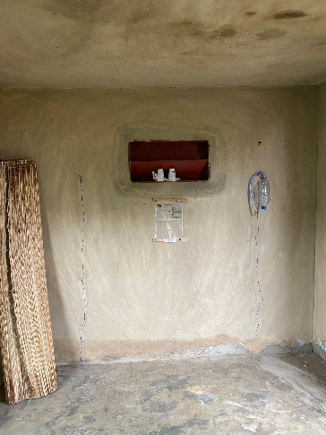
Image1
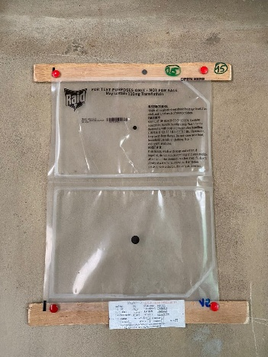
Image2
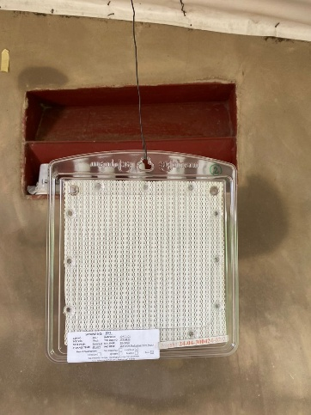
Image3

